# Knowledge GAP Dashboard

Overview

Knowledge GAP (Gap Analysis Program) Dashboard is designed to improve the training / re-training to the customer engineers by applying text clustering technique to the data from portal system. The dashboard tends to help users find out what are the most frequent questions that customer engineers have. Therefore, the users could make training plan focus on these questions.

Background

Field Support Specialist (FSS) team I worked for is the customer service team in the EMC Corporation. It is responsible for providing technical support for customer engineers who diagnose, implement, and install EMC software and hardware products on the customer sites. The team also provides training for customer engineers. I came into the team as a data analyst with a goal to help improve the training efficiency for the customer engineers.

Methodology

I conducted a contextual interview with my manager to articulate the project goal. During the interview I asked his expectation for the project deliverables, the target audiences for the project and the resources we current have including data source and the platform. After this interview, I defined that the final deliverable is a dashboard with a completely documentation, the audiences are the managers in FSS team, the data comes from FSS portal system and there is no existing platform on the team.

Next step for me is to explore the data dumps file from FSS portal system. I used Tableau and Python to explore millions of service requests that customer engineers submit in portal system. Finally I decided to apply text-clustering technique to the requests. By doing so, the requests could be divided into several groups that are defined as knowledge gaps that customer engineers have. During this process, I also found out ten valuable fields from one hundred fields for text-clustering and dashboard development.

I used Library NLTK, Scikit-Learn to complete data manipulation and text clustering, Matplotlib to draw histogram in the dashboard, wxPython to develop the dashboard interface and use py2exe to convert python script into the executable Windows programs.

Results

Dashboard Welcome Page

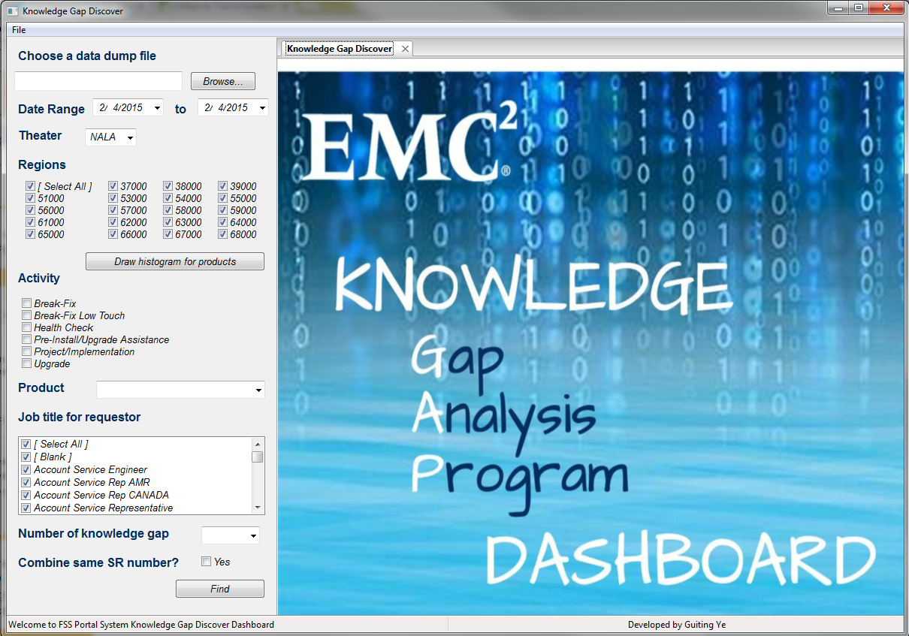

Histogram

Products histogram will help users generate general ideas about requests. For example, what are the top 10 products in the portal system and which activity the top 10 products receive most requests. 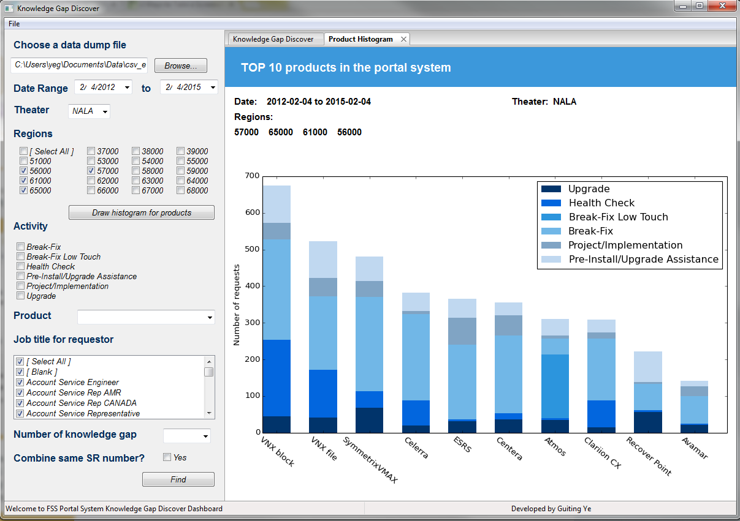

Knowledge Gaps Display Page

After users choose filters from left side and click find button, the knowledge gaps will show on the right side.

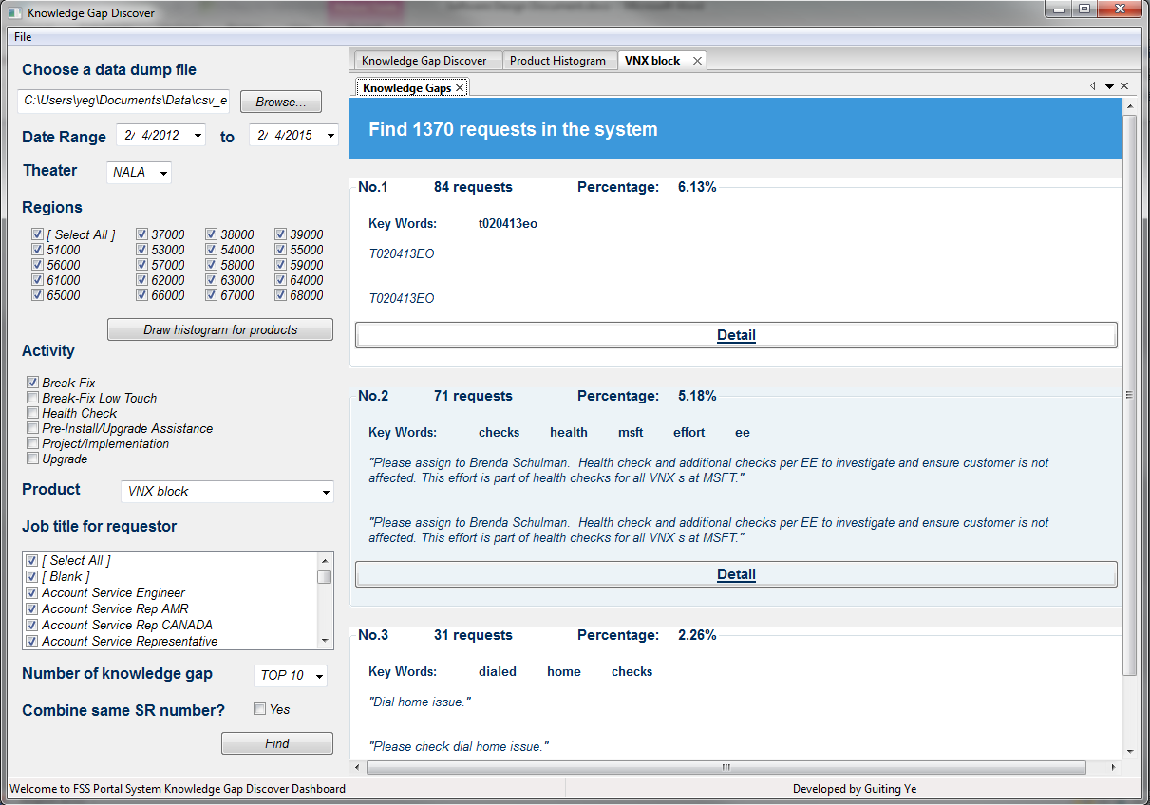

Knowledge Gap Detail

When click detail button, the dashboard will show which requests are contained in this knowledge gap.

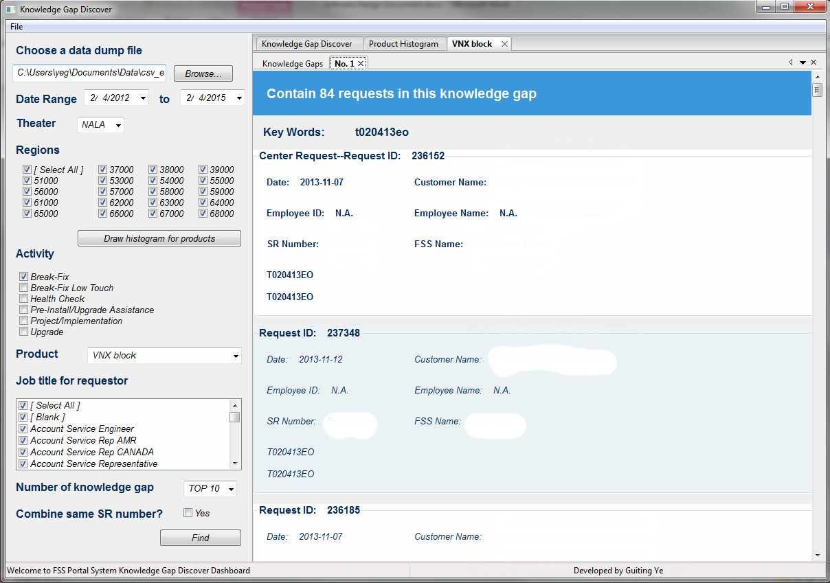

Documentation

I wrote a complete document about dashboard architecture, design and usage. This document could be used for future maintenance and update.

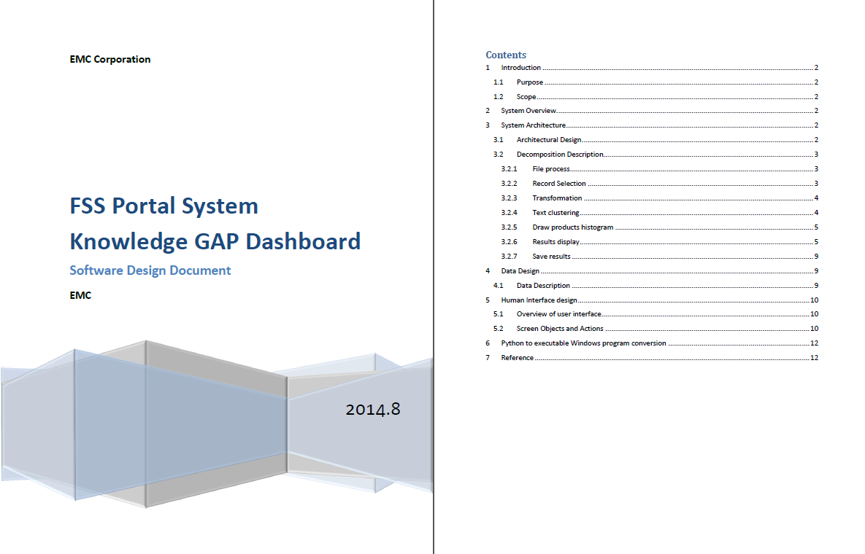

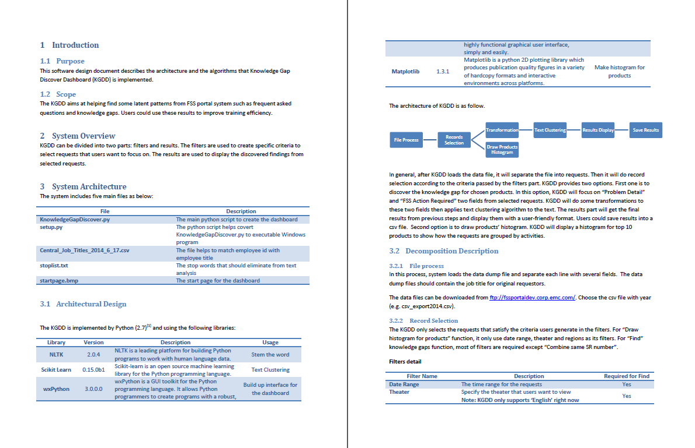

# Experience Analytics Showcase

Information Architecture, Web Design & Development

Date: September 2014 – October 2014

Type: Work Project, EMC Corporation, Total Customer Experience (TCE) Team

Skills: HTML, CSS, JavaScript, Multi-disciplinary Team Collaboration

Live Site: https://www.emc.com/microsites/tce-experience-analytics/index.htm

Experience analytics showcase is a microsite under EMC.com. This site is used to display analysis techniques that EMC uses to improve the customer experience.

I collaborated with marketing team to discuss the information architecture of the website to effective marketing TCE brand not only in EMC Corporation but also among the customers. I also worked with product team on the website development.

I received an Excellence @EMC Silver Level Award because of my extra efforts and positive impact on TCE customer experience day.

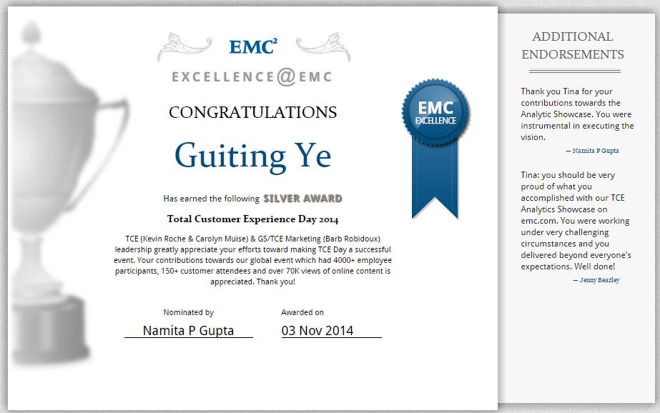

Demo

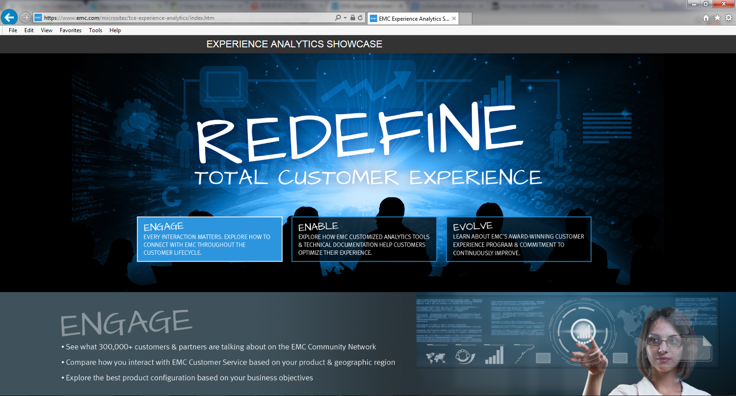

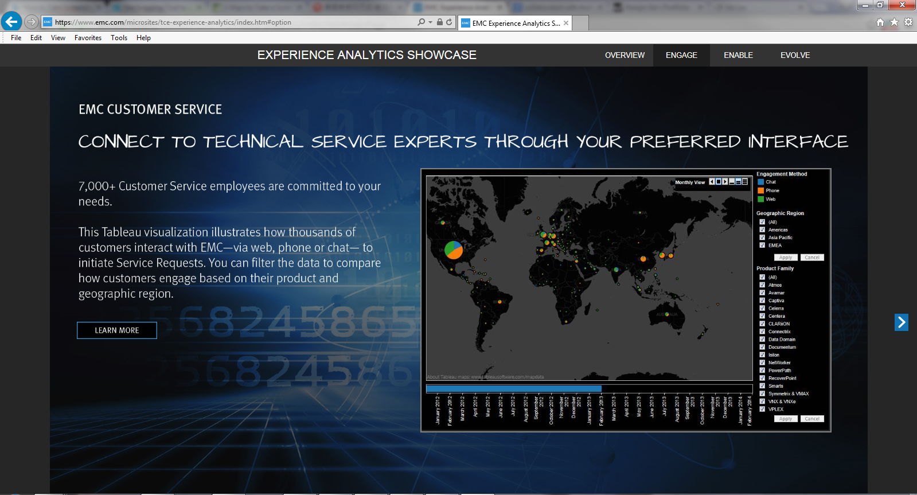

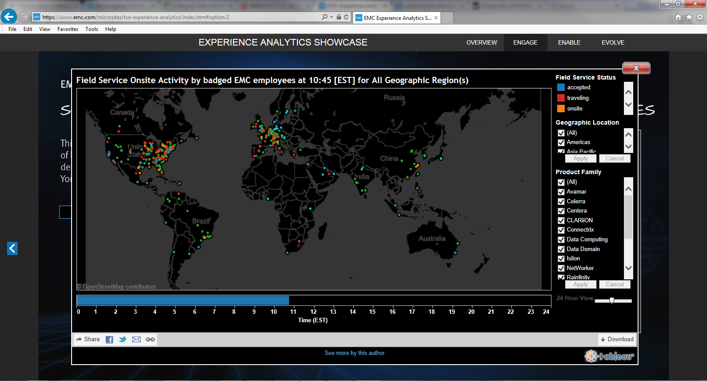

# Customer Experience Analysis

Data Analysis, Data Visualization

Date: November 2014 – Present

Type: Work Project, EMC Corporation, Total Customer Experience (TCE) Team

Skills: Market Basket Analysis, Reliability Analysis, Tableau Dashboard Design and Development, R

Total Customer Experience team is focus on exceeding customer and partner expectations for EMC. The team closely collaborated with marketing, sales and engineering team.

Competitive Intelligence Analysis

We conducted industry survey each quarter to get industry information. After analyzing the questions on the survey, I suggested to apply market basket analysis on question “Which of the following information technology vendors does your company currently use? (Select up to three.)” I thought through this way, we could help sales team to better understand market shares for information technology vendors, get ideas of customers select patterns when they choose information technology vendors and discover the collaborative relationship among vendors.

I wrote R script to conduct market basket analysis and discover some rules from survey data.

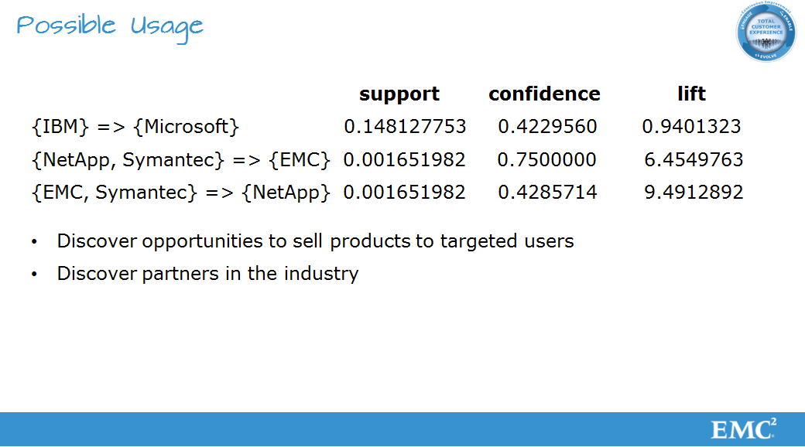

I also design the network graph to present the relationships among vendors. Each circle presents a vendor. The size and the vertical position of the circle are used to present how many users choose this vendor. If a user chooses two vendors at the same time, there is a line between these two vendors. The weight of the line presents the number of users choosing these vendors at the same time. The histogram below shows frequencies of vendors or vendors’ combination being chosen.

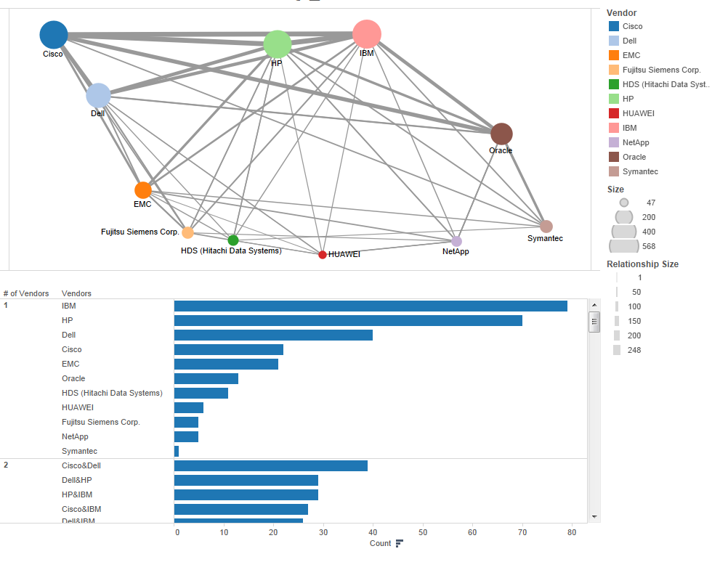

Reliability Analysis

We use service request data to monitor whether the products on the customer site are under control. In the project, I mainly use Shewhart chart- U-Chart to implement the control process. I also embed R code into Tableau so that the dashboard could take results from R code.

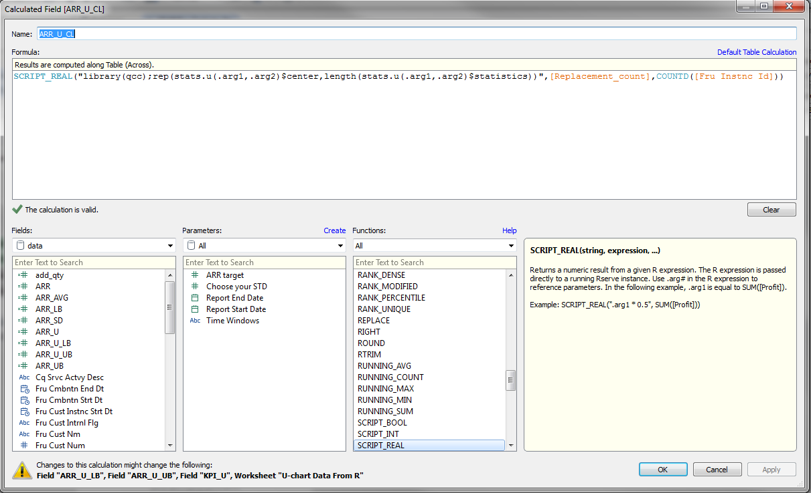

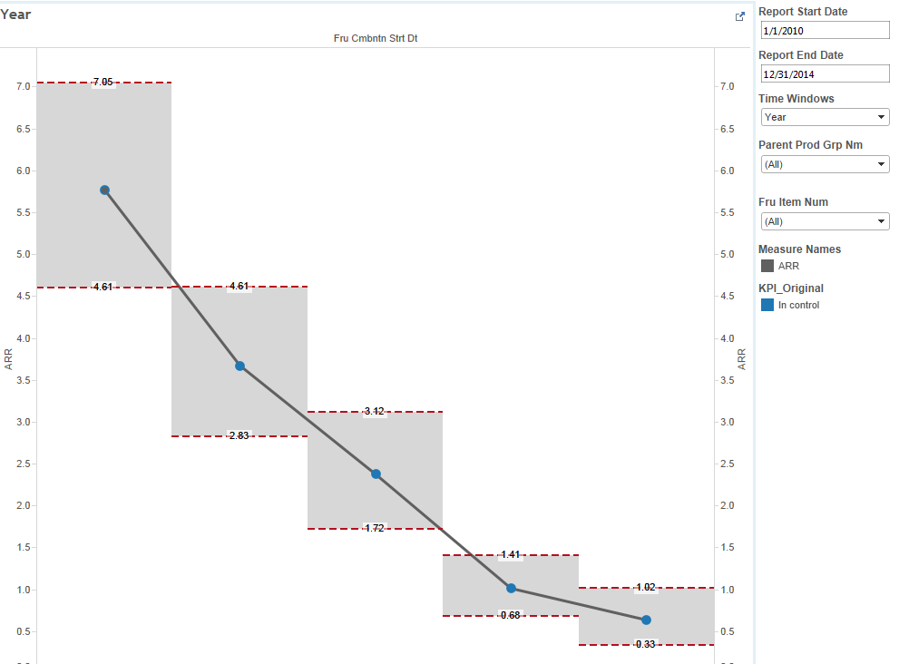

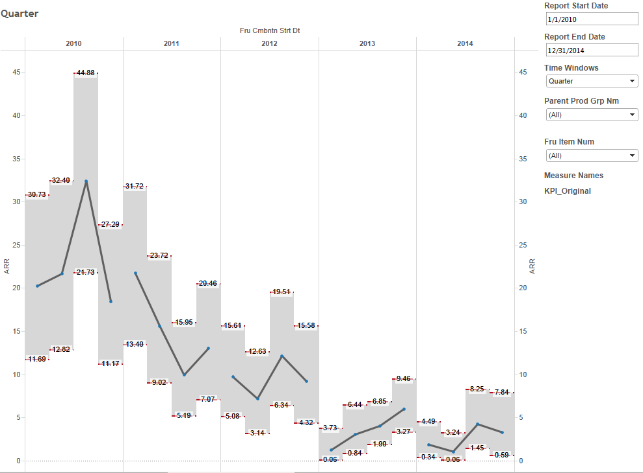

# Project Experience V.S. Career Development

Data Analysis, Data tool development

Date: June 2013 – August 2013

Type: Intern Project, University of Michigan - College of Engineering

Skills: PHP, MySQL, LinkedIn APIs, Regress Analysis, Factor Analysis

This is my summer intern project. The project goal is analyzing possible relationships between alumni’s team based engineering project experience and their career history. In the project originated a well-documented data collection tool to retrieve alumni’s profile information through LinkedIn APIs using PHP, MySQL, and HTML&CSS. I defined career and academic variables by applying cluster analysis and factor analysis. Finally, I created an analysis methodology to identify relationships between undergraduate collegiate experiences and subsequent post-graduate professional growth.

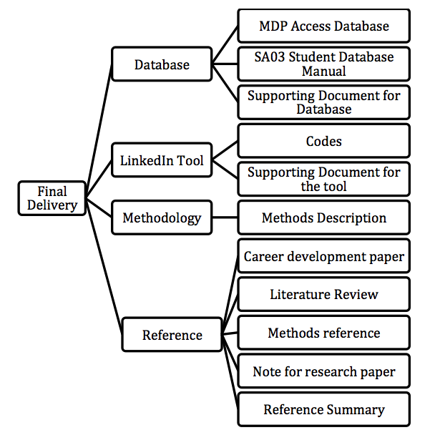

# Student Database

Database Design, Data Managment

Date: January 2013 – April 2014

Type: Part-time Project, University of Michigan – College of Engineering

Skills: Database Design, Database Management, SQL, VBA, Access 2010

The Multidisciplinary Design Program (MDP) is a program under College of Engineering University of Michigan. The program is for highly motivated students who want real experience and real credentials. I worked here as a computer consultant to help design the student database to manage the students records who participate into the program.

I built this database based on Access 2010. In order to use it as a small information system, I built interface based on the form function in Access and embed SQL script into VBA code to implement the data management.

Now the database has put into daily use. It serves to management the demography, event, and course information for the MDP program.

Demo

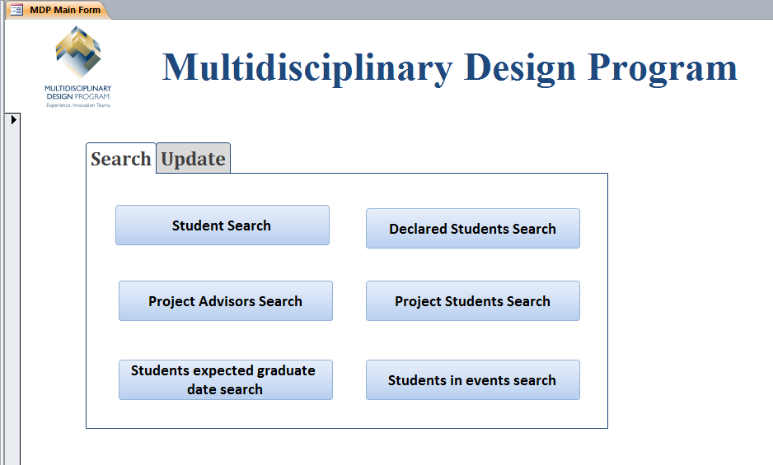

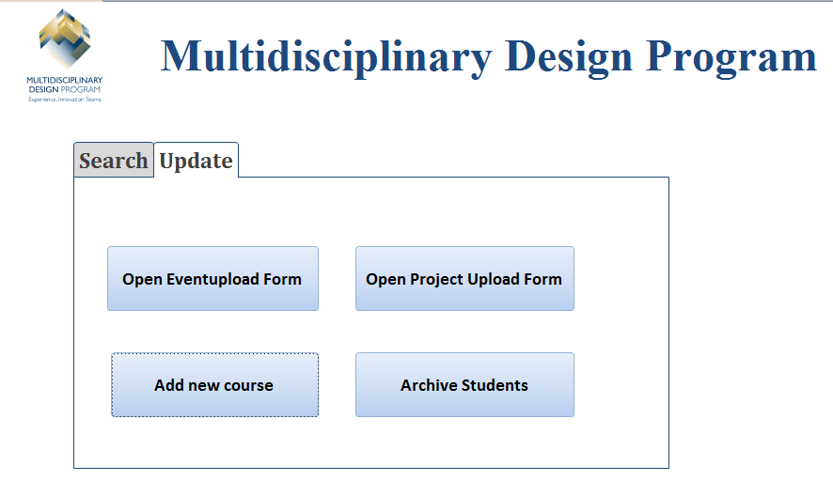

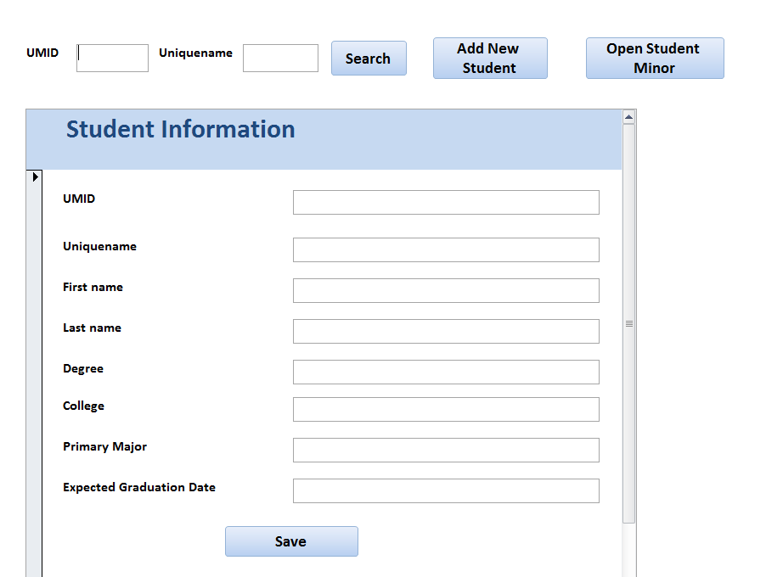

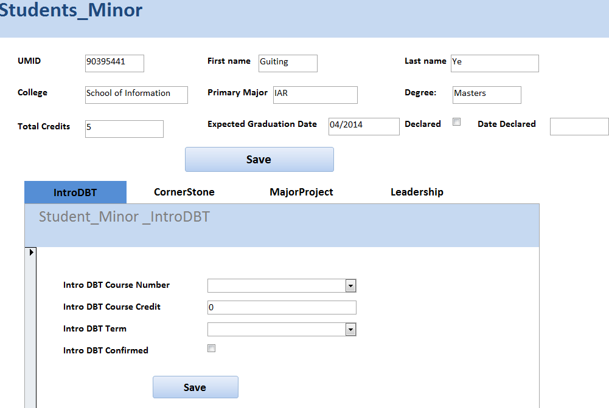

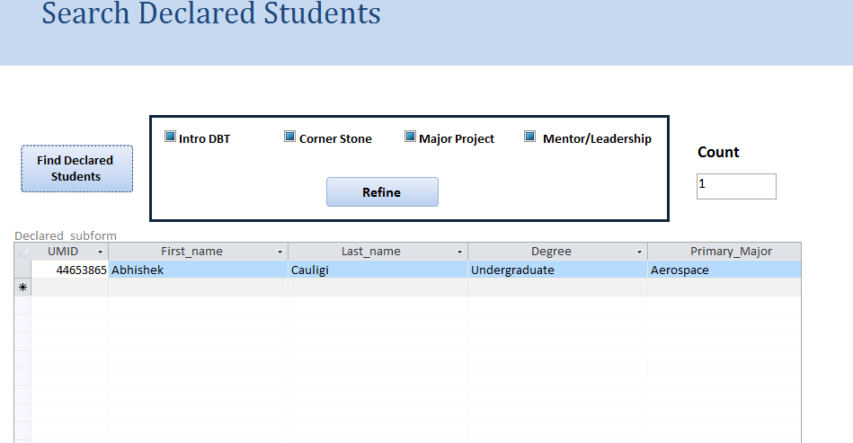

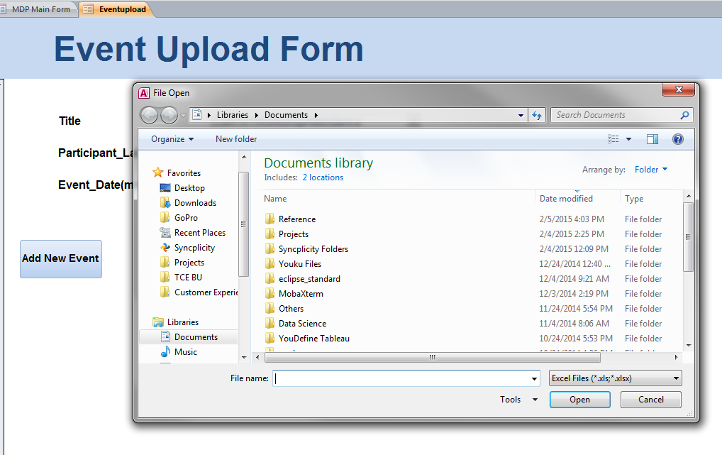

# Jobble Map

Information Visualization, Data Manipulation

Date: September 2013 – December 2013

Type: Course Project, University of Michigan – School of Information

Skills: Information Visualization, Python, JavaScript, D3.js

This interactive visualization we designed is called Jobble Map. The website provides occupational information in all the states of United States in 2012, based on data from Bureau of labor statistics, Department of Labor.

The system allows users to explore the occupation information and evaluate the employment situation in the states from four dimensions: job opportunity, job popularity, salary, and unemployment rate. At the same time, the system also provides users a way to make comparison among states. Through using our visualization, users target several ideal states.

Our goal is to help job seekers complete the first step of the job search that targets several ideal states.

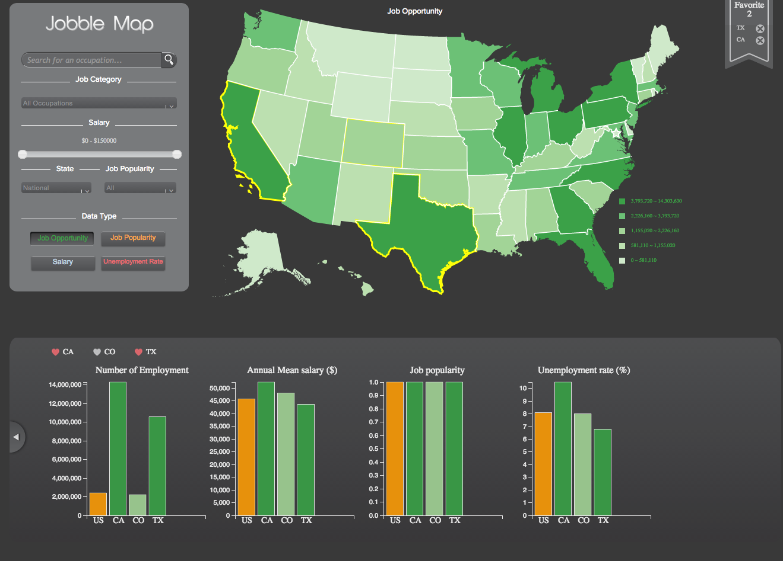

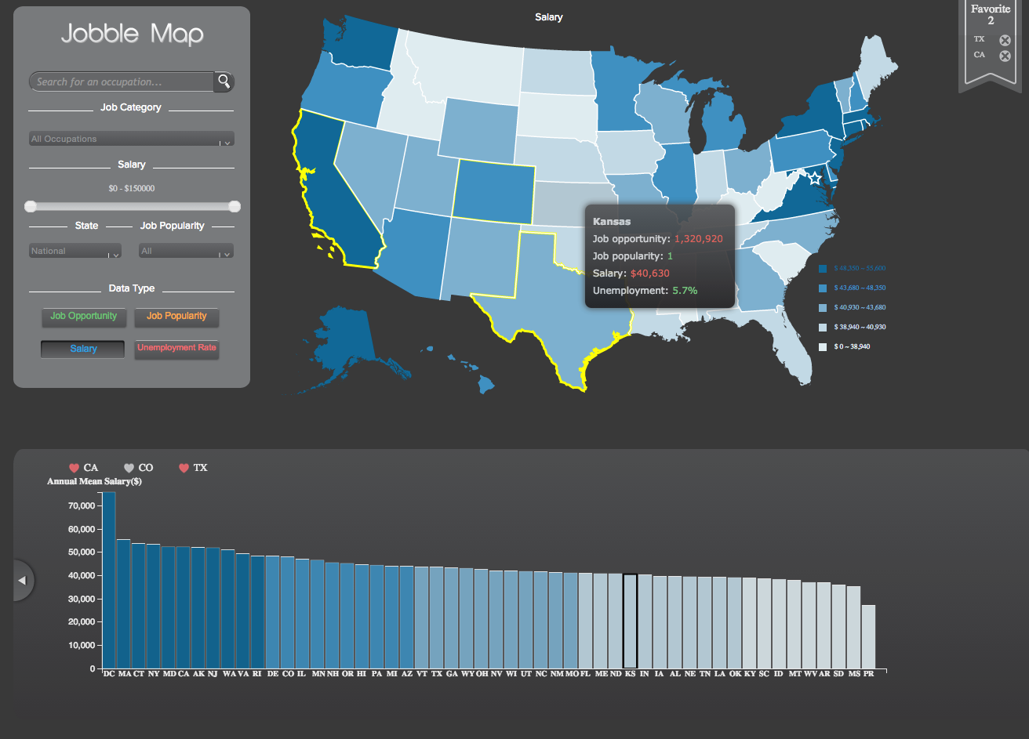

# Accenture Consulting

Database Design, Data Management

Date: August 2011 – April 2012

Type: Intern Projects, Accenture Consulting

Skills: Metrics design, Data Model, Communication

Shared Service Center

During the last year of my undergraduate studies, I landed a consulting internship with Accenture. As my first project, I was responsible for planning a Shared Service Center (SSC). We conducted a survey to get ideas about the comprehensive service information from customers. In the survey, our client provided score for each service from several aspects, for example, the volume of daily, the quality of the work, the management type of the work, and the functions of the job. Then I grouped them into value, potential and difficulty. Value means how much value this business will bring if it put into SSC. Potential presents the likelihood to bring the services to SSC. The difficulty means the difficulty of the works. We would calculate the average scores for these three sides. If all the average score is smaller than 2 we think this service should put into the shared service center. However, when we use average score, it could not well differentiate the services that should put into shared service center from which should not. Thus, I suggested assign each aspect of service with different weight, and then to calculate the weighted average for the value, potential and difficulty. The final results show this method works better.

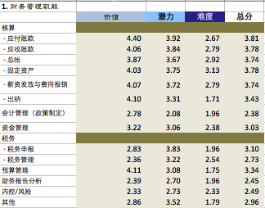

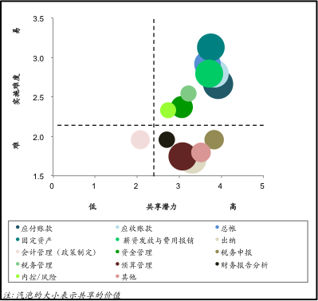

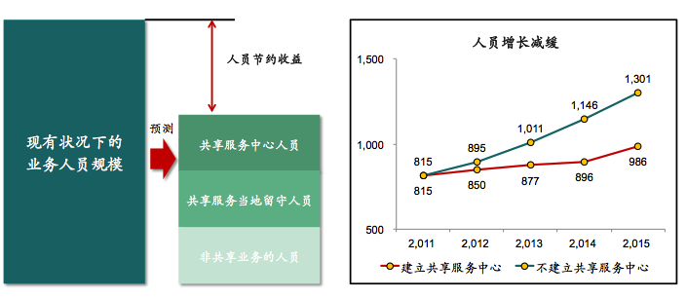

Financial Budget Model

The financial budge model is built on excel. The customers could use this model to predict the sales for the product after they provided some we would show them the financial statements, such as cash flow statement, balance sheet and so on.

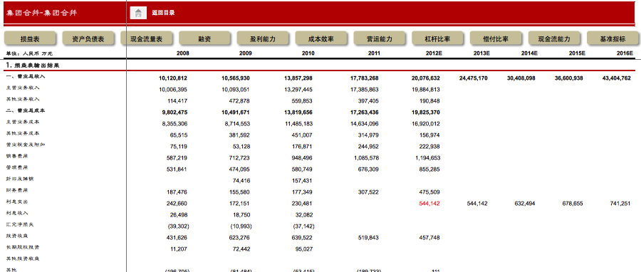

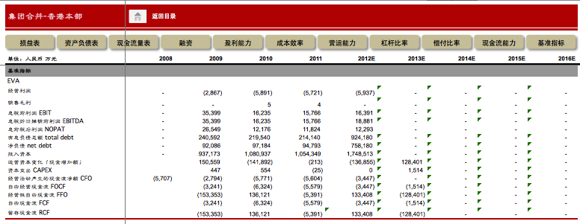

# Smithsonian Gardens

Data Analysis, Web Traffic Analysis

Date: March 2013

Type: Volunteer Project Smithsonian Gardens

Skills: Statistics Analysis, Google Analytics

It’s a spring break volunteer program to help Smithsonian Gardens to analyze its web and social media. Smithsonian Gardens. I extracted statistical data from Web Trends, Google Analytics and Constant Contact. I mainly focus on analyzing Smithsonian Gardens' current service offerings, including web site and social media. At the end of the project, I provided suggestions to utilize web site and social media more effective according to the analysis results.

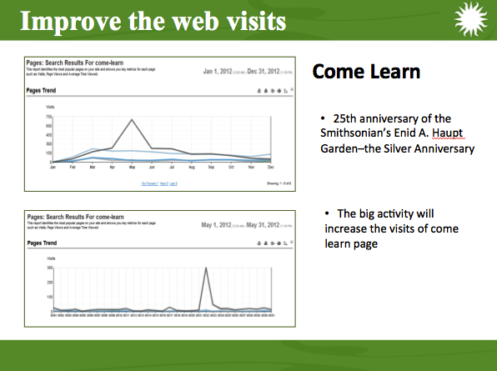

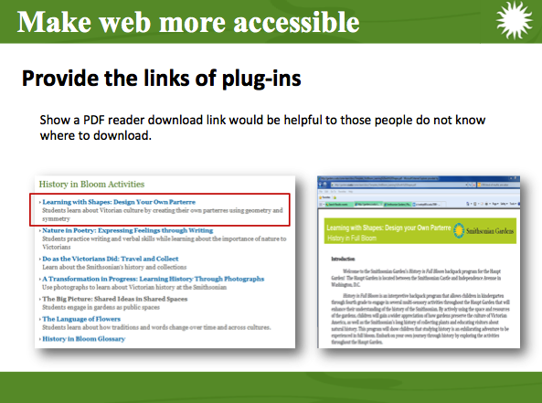

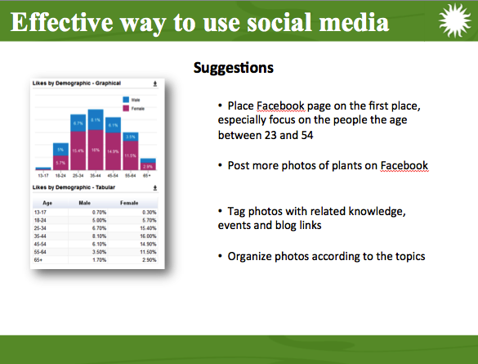

# Nutri+

Database Design, Web Application Development

Date: January 2013 – April 2013

Type: Course Project, University of Michigan – School of Information

Skills: Database Design, PHP, MySQL, HTML, CSS, JavaScript, Information Visualization

The project aims at building a platform to provide the information of food nutrition and what/how much the body requires to help users understand what they eat. Through this way, we could help people develop a healthy eating habit according to what they need.

We created the use case to define the interactions between the user and our website.

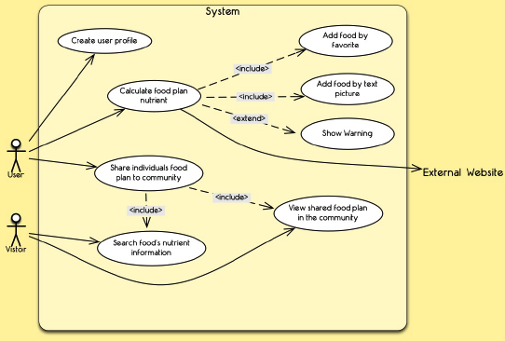

We created the workflow to define how the users achieve their goals in our website step-by-step.

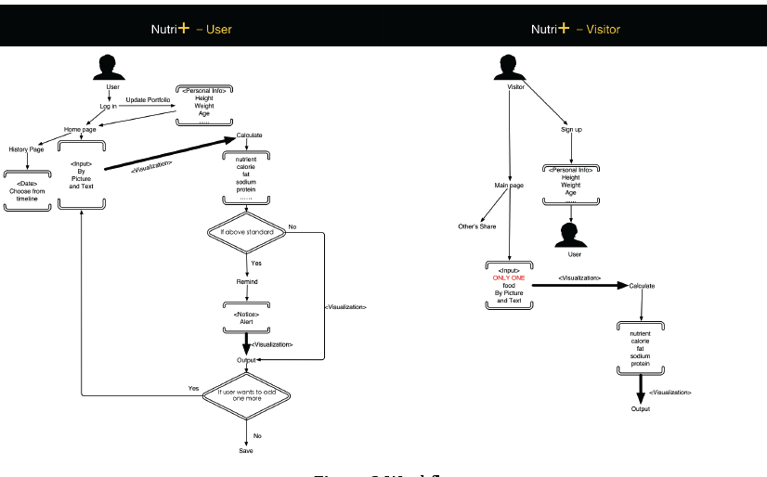

According to the scope of our website, we analyzed and determined the data requirements, and built our database schema.

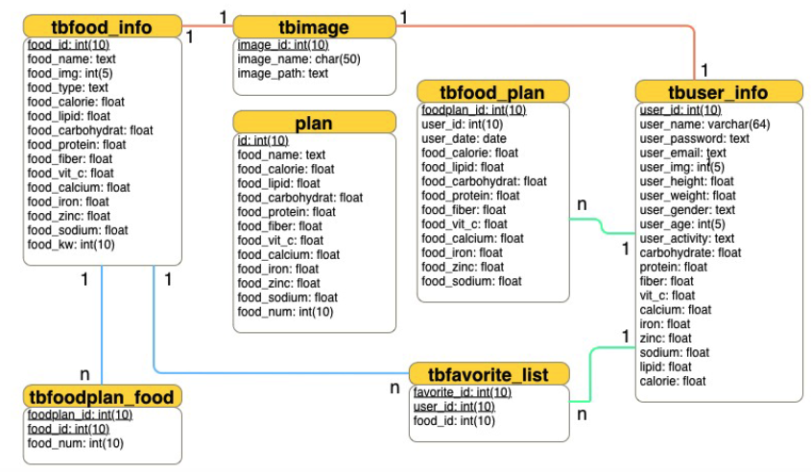

Based on data structure we created the database in MySQL.

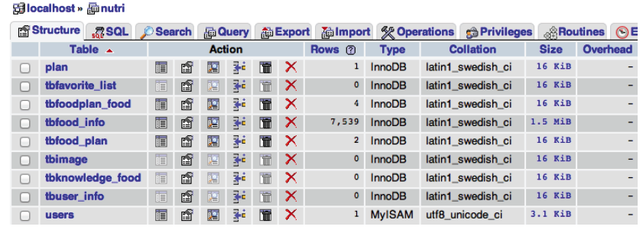

We created a series of website pages and functions, including login in/out, register, meal plan, nutrition report, timeline and profile.

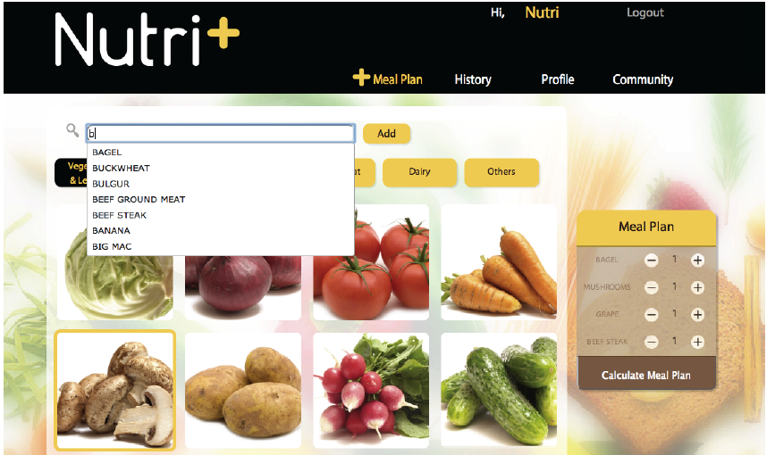

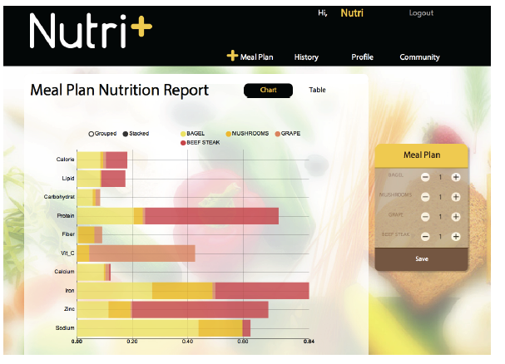

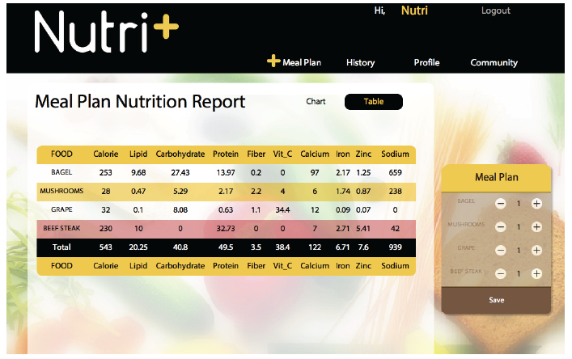

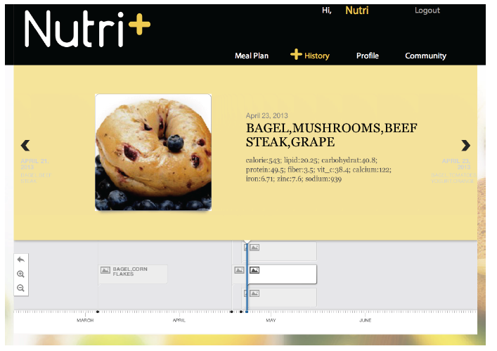

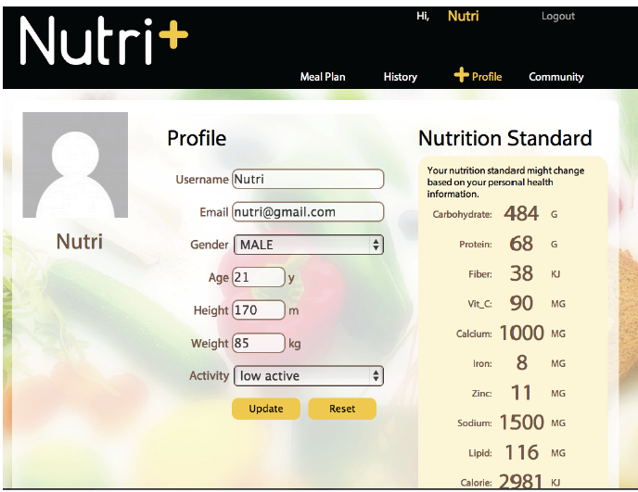

# Library Search Engine

Information Retrieval, Search Engine Evaluation

Date: January 2013 – April 2013

Type: Course Project, University of Michigan – School of Information

Skills: Database Design, PHP, MySQL, HTML, CSS, JavaScript, Information Visualization

The project goal is to build a search engine for library, and find out which algorithm is better for library search system. In the project, we compared the BM25 and Language Model (Bayesian smoothing using Dirichlet priors) and see which one is better.

We use “Harvard Library Bibliographic Dataset” (http://openmetadata.lib.harvard.edu/bibdata), which contains over 12 million bibliographic records for materials held by the Harvard Library. Since we have limited compute resource, we only used 0.1 million of them.

We decided to use Lucene 4.2 (which was released on Marth 11th, 2013) to build our search engine. The entire search engine used two search algorithms: BM25 Similarities and Bayesian smoothing using Dirichlet priors Language Model Similarities. We chose ten topics for search engine evaluation. Among the algorithms we tested, We found that the system with BM25 without adjusted weight has the best performance.

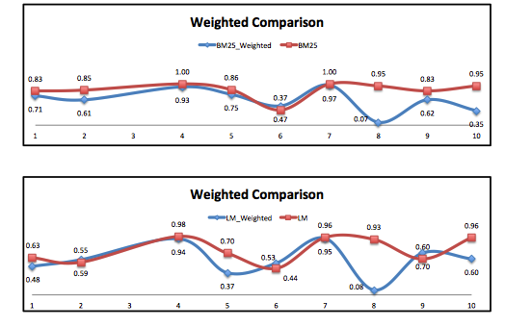

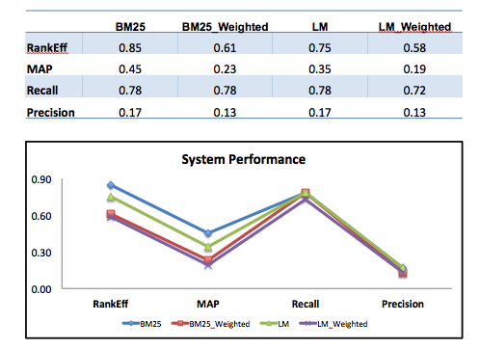

# Michigan Club Council

Project Management, Contexture Inquiry

Date: September 2013 – December 2013

Type: Course Project, University of Michigan – School of Information

Skills: Project Management, Contexture Inquiry

The project is focus on improving communications involving the University of Michigan Alumni Association Clubs Council. The Clubs Council is a 13-14 person volunteer group that was set up to aid the Alumni Association in its interactions with the roughly 70 University of Michigan Alumni Clubs that exist throughout the United States. The Alumni Association supports and funds the alumni clubs as they hold activities for their alumni throughout the year.

To gather information we interviewed eight alumni network members, including AA employees, CC members from both Virtual and Metro Clubs, and Alumni Club presidents. We also observed a semiannual meeting of the CC. After each interview we collectively analyzed our data, evaluating the organizational structure, culture, and communication practices.

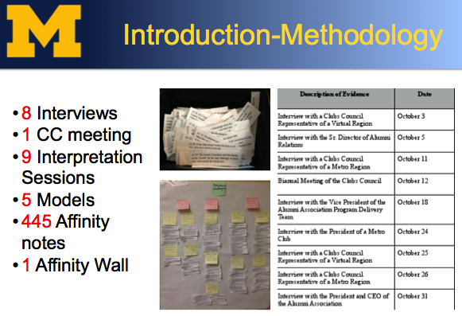

Finally we provided three main recommendations based on the findings. The first is to clarify the roles of the CC (Clubs Council), the second is that the individual clubs should schedule a designated amount of time just for CC business and information into their meetings, and the third is to reorganize Virtual Regions by proximity instead of by club size.

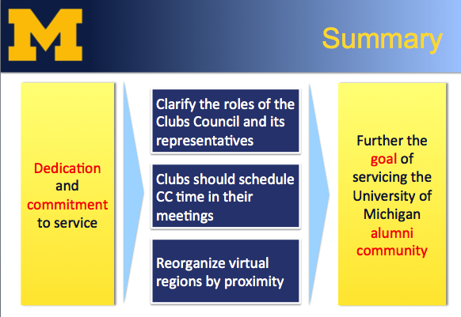

# Data Science Certification

Data Science

I gained EMC Proven Professional Data Science Associate on July 2014.

